21.62: 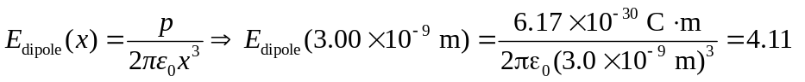
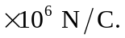 The electric force 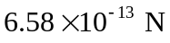 and is toward the water molecule (negative x-direction).

